CSC 485/585 Homework #3

Turing Machine Construction and encoding

Please show the graph of the machine with all edges labeled and please provide a brief description of the purpose of the states in your machines (see below). You must use JFLAP to construct your Turing Machines.

For each TM you build, please add a BRIEF English description of how it operates. Make your English description as clear as possible! Please note – this homework may take some time so please get going on it SOON.

- Construct a TM that recognizes the non-CFL language L = {wcw | w is in (0+1)*} and halts on all inputs. Please briefly explain the purpose of each state of your machine. So, for example the string 1110c1110 IS in L but the string 0010c0110 is NOT.

= There are 2 paths that the machine would follow, 1 and 0, both for reading. First, the first 1 or 0 is removed as the machine reads. Then, it moves rightward until it finds the ‘c’, after which it searches for the first occurrence of the same digit on the right side and replaces it with X. The machine has separate paths for handling 0 and 1, ensuring the correct digit is matched and marked. Once this process is completed, the TM moves back to the leftmost side, skipping over already processed cells, and repeats the same steps until all digits are processed.
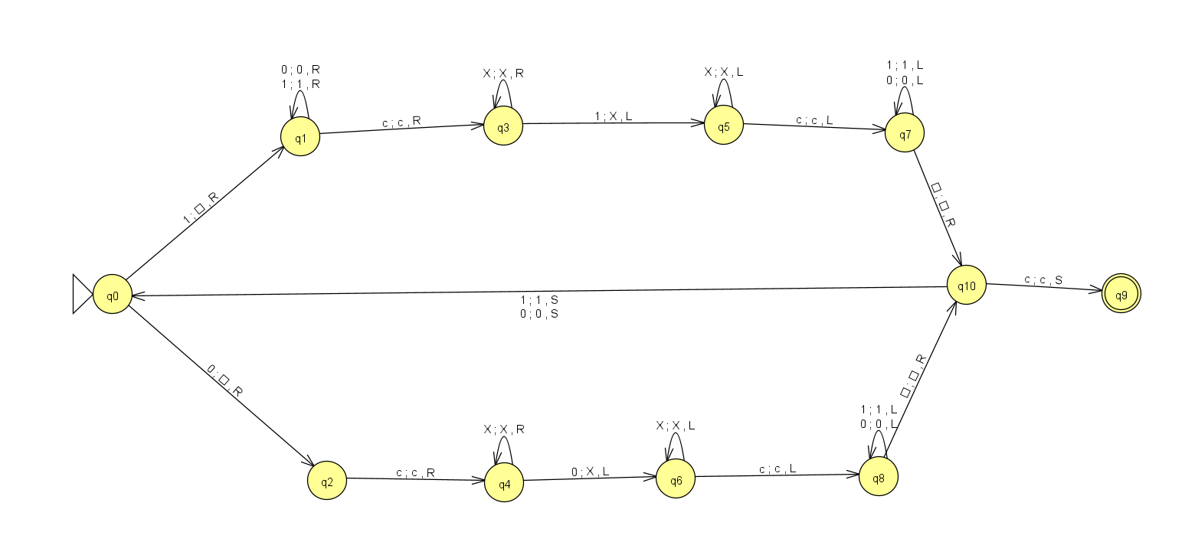

2. Construct a TM that expects a string of 0’s and 1’s and interprets the input value as some binary integer X. Your TM should halt and end with the binary representation of 4X +1 on the tape. For example, if the machine was started with 1101 (binary for 13) on the tape then it would halt with 110101 on the tape (binary for 53). If the machine was started with 1010 (binary for 10) then it would halt with 101001 (binary for 41) on the tape.

=
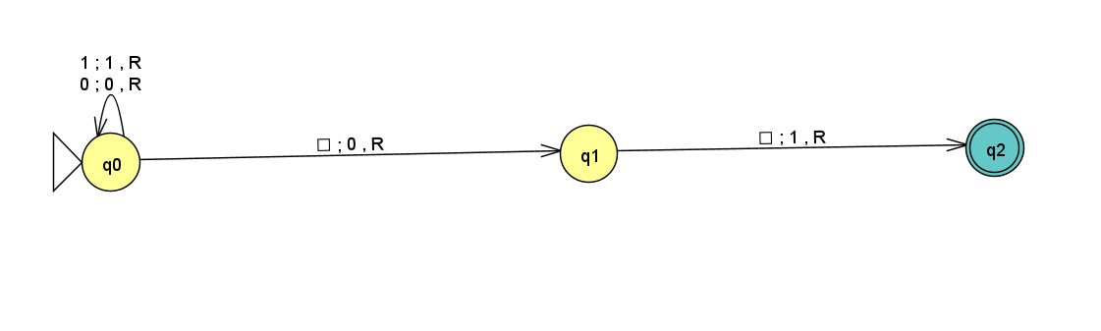

When one of the given inputs, for instance, 1010 (binary for 10) is provided, the TM calculates 4X+1 as follows:
The machine starts at the leftmost digit and moves right, skipping over the digits of the input until it reaches the first blank space. Here, it appends 0 to the end of the string to begin the multiplication by 4. Then, it moves to the next blank space and appends another 0, completing the 4X operation. Next, the machine moves to the next blank space and writes 1, adding 1 to the result. This appends 01 to the end of the input, changing 1010 into 101001, the binary representation of 41.

3. Suppose you had a NON-Deterministic Turing Machine that at some point was in the start state q0 over a tape that is completely blank (infinitely in both directions!!!) except for one cell which contains a # symbol. If the read/write head is currently over a blank cell and you do not know where the # lies with respect to the current position then what would you need to do to move the read/write head so that it is over the # and in a final state? How would you accomplish this? Build the NON-Deterministic machine that will halt with the R/W head positioned over the # symbol.

= We don’t know whether the # symbol is to the left or right of the current position of the read/write head, so we need to search in both directions which makes it a NON-Deterministic machine. And to do this, the machine follows two paths, one that moves left and another that moves right, until it finds the # symbol.

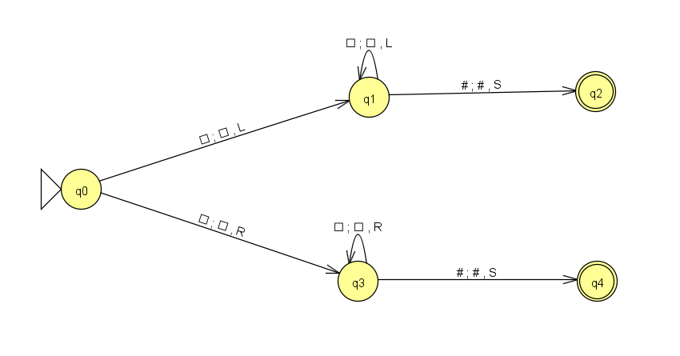

4. Solve the previous problem by building a purely Deterministic Turing machine. Explain how the machine works and how it differs from the non-deterministic version. This machine MUST be Deterministic.
= The deterministic model follows a specific sequence. When it reads an empty cell, it writes an X there and first moves left. After that, it moves right, skipping over any cells marked with X. This process makes sure that the head eventually reaches the # symbol. If the # is to the right of the initial position, the head moves right until it finds it. Similarly, if the # is to the left, the head moves left until it reaches the #.

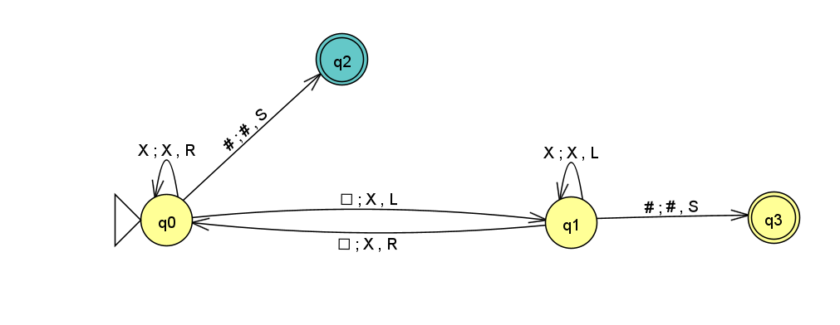
5. Easy one…. Assume your Turing machine starts with some binary string w on the input tape. Design a Turing machine that accepts if w contains an odd number of 1’s and rejects if w contains an even number of 1’s. So 110101000 would be REJECTED (4 1’s) and 10010010000 would be ACCEPTED (3 1’s).

= Since the string is a binary string with an odd number of 1s, it must contain at least one 1. The machine reads the input until it finds the first 1, then switches back to the previous state upon reading another 1. This machine makes sure that the machine does not reach the final state if the number of 1’s is even.
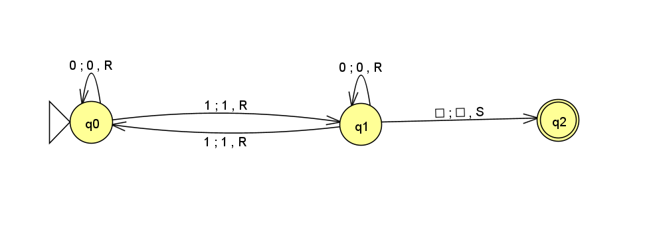

7. Using the encoding technique taught in class and in the slides, encode the following Turing Machine. Provide the 5-tuples of integers for each transition of the machine along with the entire machine's final binary encoding.

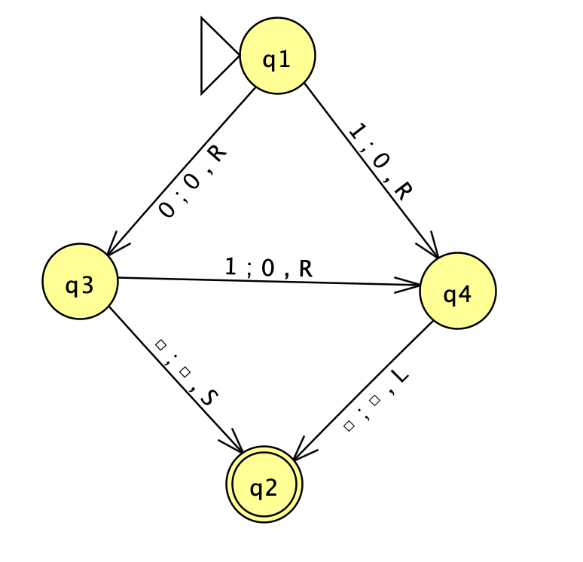

Following are the delta transitions:
δ(q1, 1) → (q4, 0, R) == (1,3,4,2,2) == 0100010000100100
δ(q1, 0) → (q3, 0, R) == (1,2,3,2,2) == 01001000100100
δ(q3, 1) → (q4, 0, R) == (3,3,4,2,2) == 000100010000100100
δ(q3, blank) → (q2, blank, S) == (3,1,2,1,3) == 00010100101000
δ(q4, blank) → (q2, blank, L) == (4,1,2,1,1) == 0000101001010

Here’s the Final encoded form: (11 concatenated for states transition, 111 determines the initial and the ending state)

11101000100001001001101001000100100110001000100001001001100010100101000110000101001010111

